**Experiment 4**

**TITLE:** **DDL (Data Definition Language) commands with Data Constraints**

**Objective:** To understand the concept of data constraints that is enforced on data being stored in the table. Focus on Primary Key, The Foreign Key and constraints.

Review this diagram

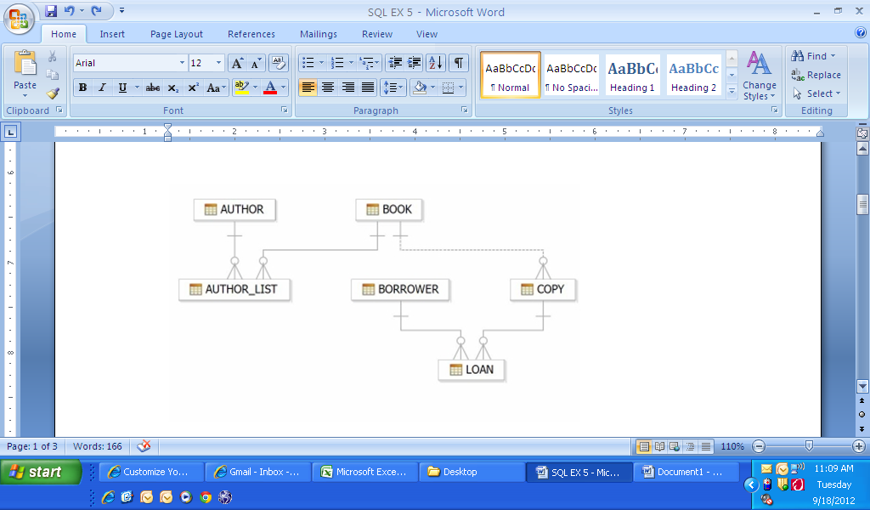

1. Create table AUTHOR = {Author_ID , Lastname, Firstname, Email, City, Country}

Where:

Author_ID – text data type, 5 characters, primary key

Lastname – text data type, 15 characters, not null

Firstname – text data type, 15 characters, not null

Email – text data type, 40 characters,

City – text data type, 15 characters,

Country – text data type, 15 characters,

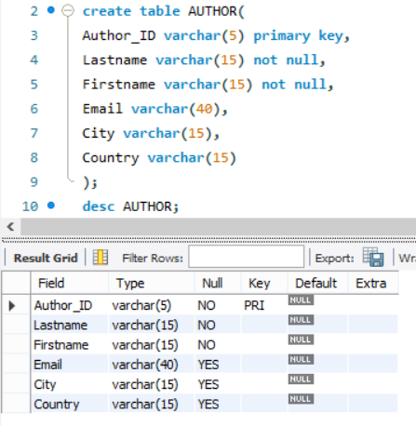

1. Create Table BOOK={ Book_ID, Book_Title, Copies)

Where :

Book_ID – text data type, 5 characters Primary Key Start With Character **B**

Book_Title - Text data Type Not Null

Copies- No.of copies Data Type int always greater the 2

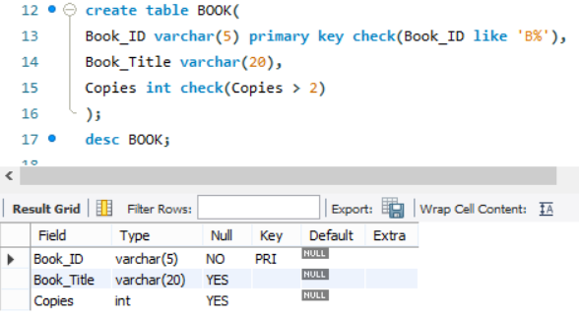

1. Create table AUTHOR_LIST = {Author_ID , Book_ID , Role}

Where:

Author_ID – text data type, 5 characters, referenced by Author_ID from AUTHOR

table

Book_ID – text data type, 5 characters

Role – text data type, 15 characters

and primary key is: Author_ID, Book_ID

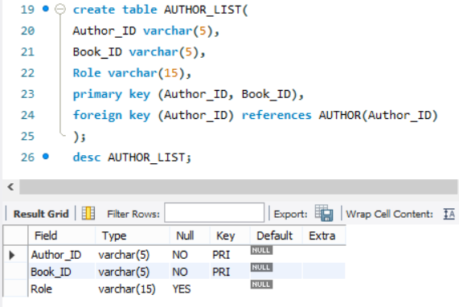

1. Add four records in each tables AUTHOR, BOOK, BOOK_LIST.

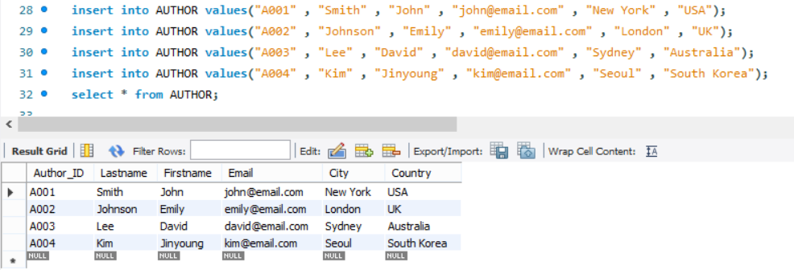

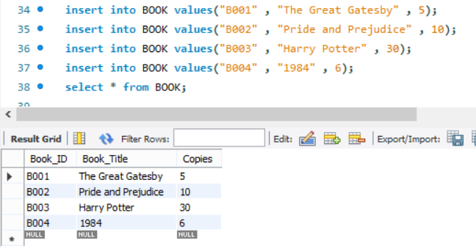

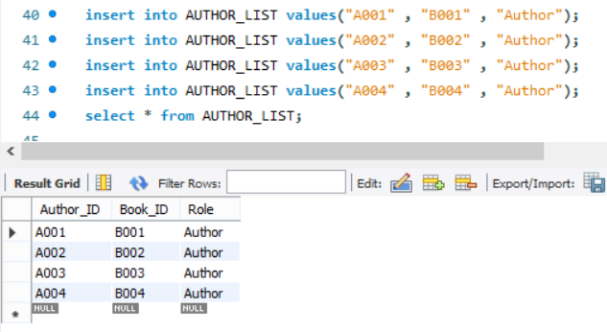

1. Alter structure of table AUTHOR_LIST add the field Publisher data type of 30 Character.

